**PROJECT REPORT**

**A COMPREHENSIVE ANALYSIS OF FINANCIAL PERFORMANCE: INSIGHTS FROM A LEADING BANKS**

1 INTRODUCTION

**1.1 OVERVIEW**

The financial performance tells investors about the general well-being of a firm. It is a snapshot of its economic health and the job its management is doing. No single measure should be used to define the financial performance of a firm.

**1.2 PURPOSE**

Its purpose is to convey an understanding of some financial aspects of a business firm. It provides financial information such as the company’s asset structure, asset liquidity, source of funds, debt level, and liability structure. Thus, according to financial tools to analyze each part of financial statement is useful for avoiding financial risks.

1. **PROBLEM DEFINITION AND DESIGN THINKING**

**2.1 EMPATHY MAP**

**Paste the empathy map screenshot**

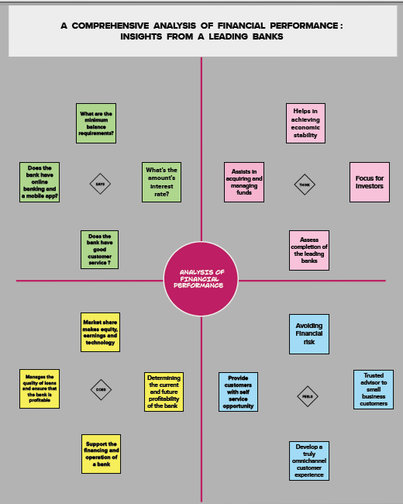

**2.2 IDEATION AND BRAINSTORMING:**

**Paste the ideation and brainstorming map Screenshot**

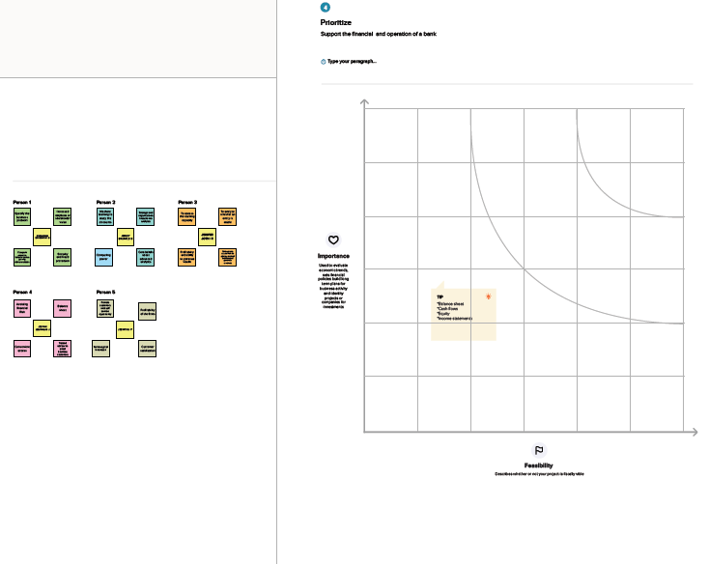

**3 RESULT**

Paste screenshot of dashboard, story and web application.

* DASH BOARD

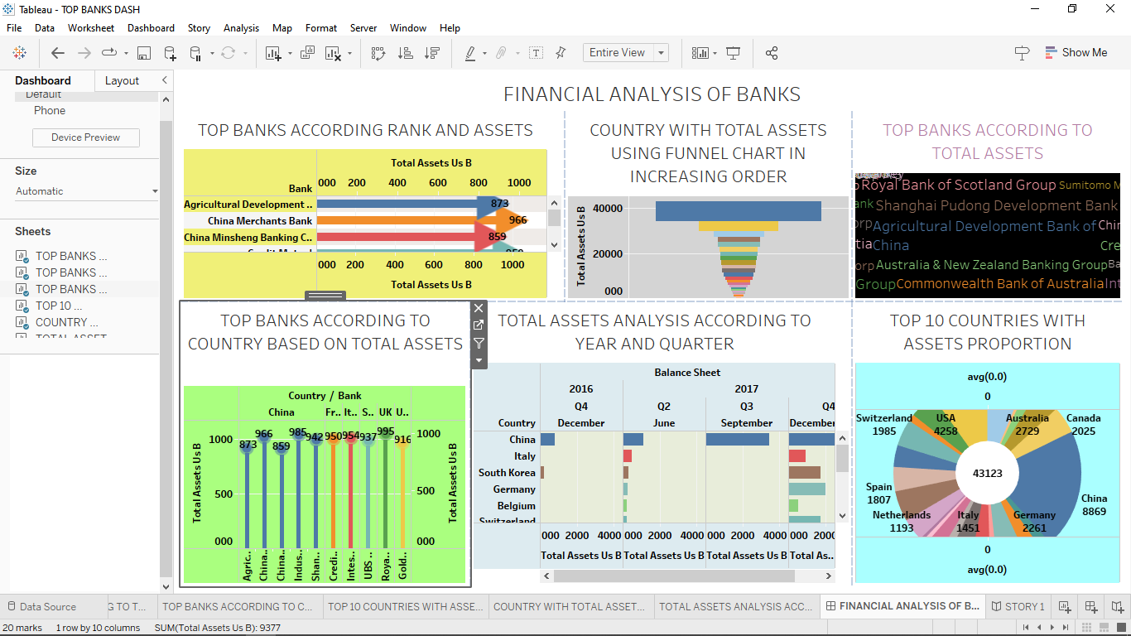

* STORY :

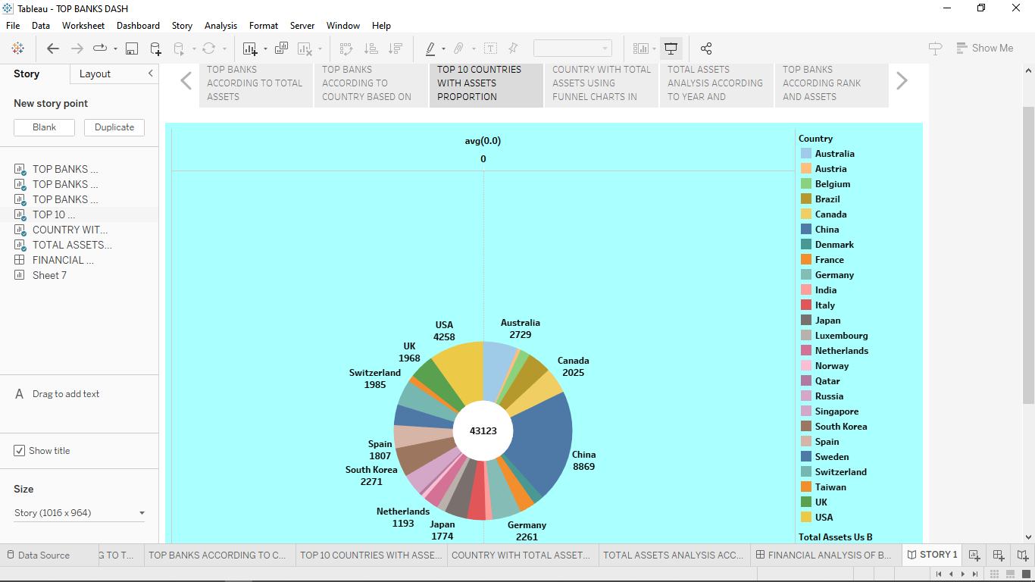

* WEB APPLICATION :

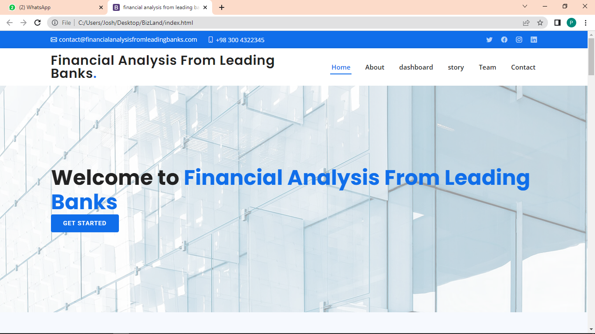

1. **ADVANTAGES AND DISADVANTAGES**

**ADVANTAGES:**

* Monitoring your financial performance therefore creates more certainty and confidence in making both short and long term decision. This in turn leads to a healthier business and faster growth rate.
* It allows you to outperform and outmanoeuvre competitors who fail in this regard.

**DISADVANTAGES:**

* Changes in government policy might occur suddenly at any time, and these changes can have an impact on the financial strategy.
* Despite the fact that financial plans are founded on assumption, there are occasions when the assumptions result in incorrect forecasts.

**5 APPLICATIONS**

Financial performance measures an organization’s ability to manage finances. It is evaluated based on a firm’s assets, liabilities, revenue, expenses, equity and profitability. Financial ratios serve as crucial indicators. It measures firms financial well-being using data provided in financial statements.

**6 CONCLUSION**

A financial performance report is a summary of the financial performance of a company that reports the financial health of a company helping various investors and stakeholders take their investment decision.

**7 FUTURE SCOPE**

Different types and combinations of information, enforcement and transaction costs in conjunction with different legal, regulatory, and tax systems have motivated distinct financial contracts, markets and intermediaries across countries and throughout history.